**DAILY ONLINE ACTIVITIES SUMMARY**

|  |  |  |  |  |  |  |  |  |
| --- | --- | --- | --- | --- | --- | --- | --- | --- |
| **Date:** | **01/07/2020** | | | | | **Name:** | **RITIKA R KULKARNI** | |
| **Sem& Sec** | **4​th​ SEM. & ‘B’ SEC.** | | | | | **USN:** | **4AL19CS403** | |
| **Online Test Summary** | | | | | | | | |
| **Subject** | | **- -** | | | | | | |
| **Max. Marks** | | **--** | | **Score** | | | **- -** | |
| **Certification Course Summary** | | | | | | | | |
| **Course** | **Learn Web Design: The Ultimate Guide For Beginners** | | | | | | | |
| **Certificate Provider** | | | **BitDegree** | | **Duration** | | | **7 Hrs.** |
| **Coding Challenges** | | | | | | | | |
| **Problem Statement:**   1. **Given two lists, sort the values of one list using the second list.** 2. **Examples: Input :list1 = ["a", "b", "c", "d", "e", "f", "g", "h", "i"] list2 = [ 0, 1, 1, 0, 1, 2, 2, 0, 1]**   **Output :**  **['a', 'd', 'h', 'b', 'c', 'e', 'i', 'f', 'g'] Input : list1 = ["g", "e", "e", "k", "s", "f", "o", "r", "g", "e", "e", "k", "s"] list2 = [ 0, 1, 1, 0, 1, 2, 2, 0, 1] Output : ['g', 'k', 'r', 'e', 'e', 'g', 's', 'f', 'o']** | | | | | | | | |
| **Status: Executed** | | | | | | | | |
| **Uploaded the report in Github** | | | | | **Yes** | | | |
| **If yes Repository name** | | | | | <https://github.com/ritikakulkarni> | | | |
| **Uploaded the report in slack** | | | | | **Yes** | | | |

**Online Test Summary:** No internals conducted.

**Online Certification course Summary​:**I have taken new Online Certification Course in **BitDegree** . Today I went through Design for Coders in that I learned basic color,Tone.



**Online Coding Summary​:Today I received one program from Prof. Shilpa Mam and Prof. Venkatesh Bhat CSE Dept.. I have written one program and uploaded it to my Github repository. This is my repository snapshot. I have uploaded the frequency program.**

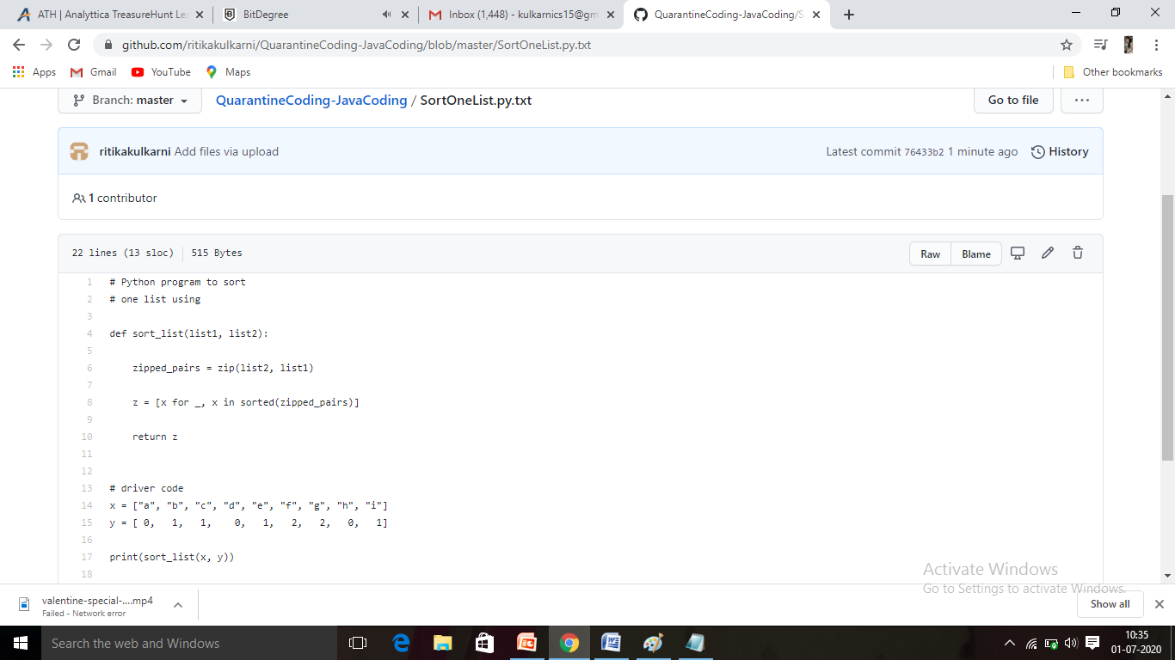

Thank you